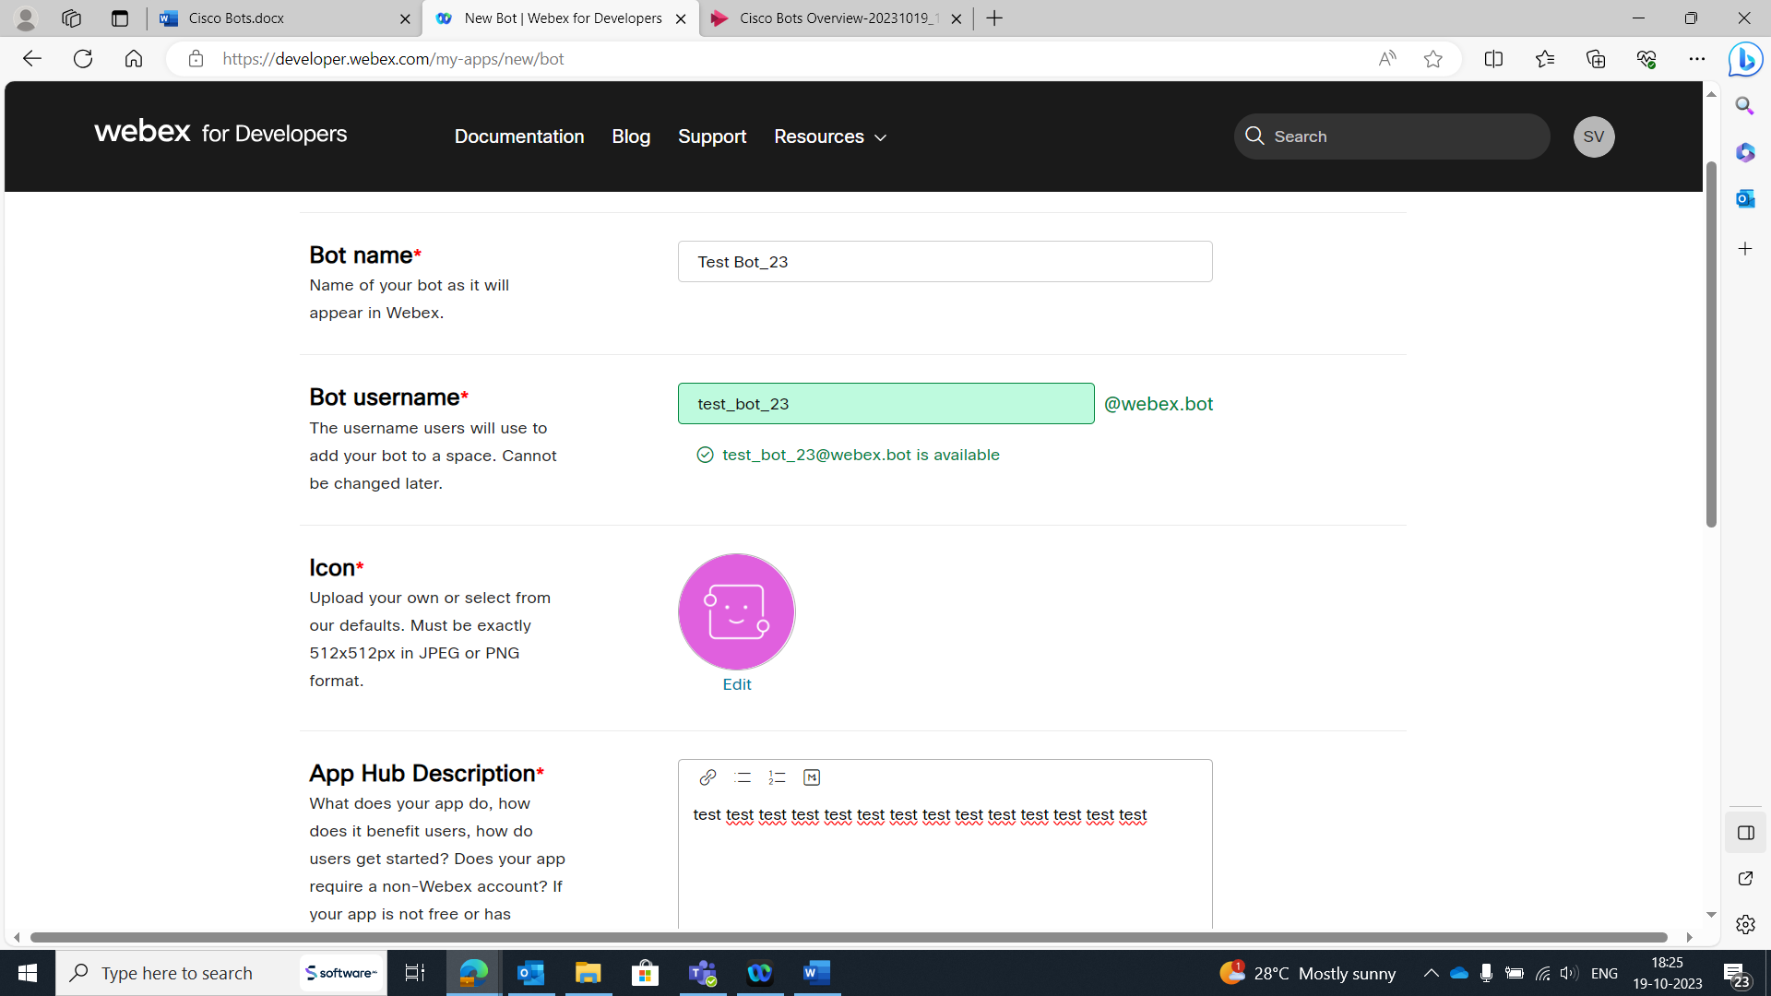

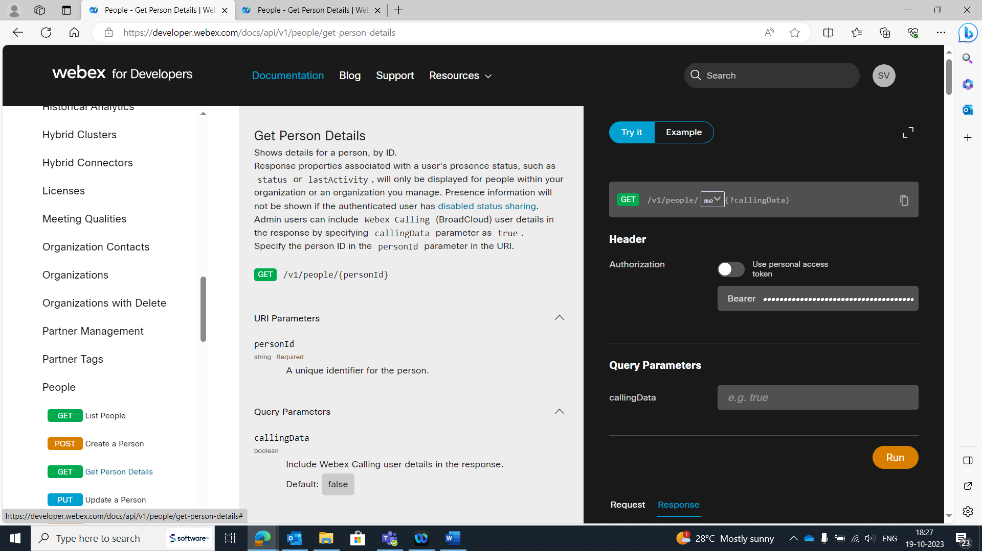

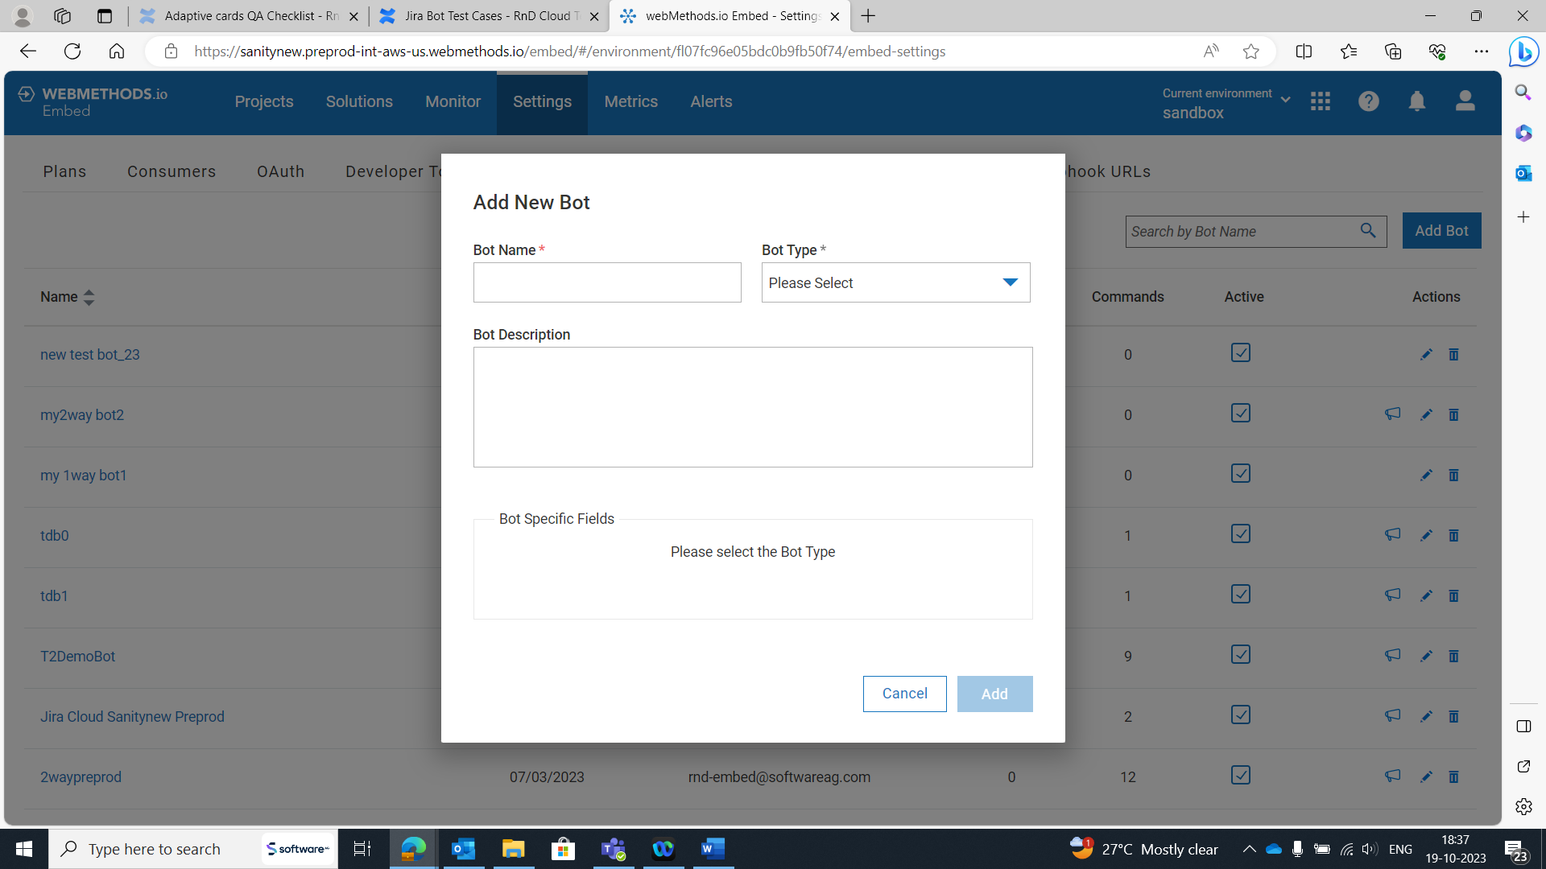

Getting blank page on Authorize Cisco Webex Teams\* (49..)

Session timeout

